Note: This is a redo of lab 1 to take into account the LVS and PEX functions of L-Edit

Cell Schematic in S-Edit
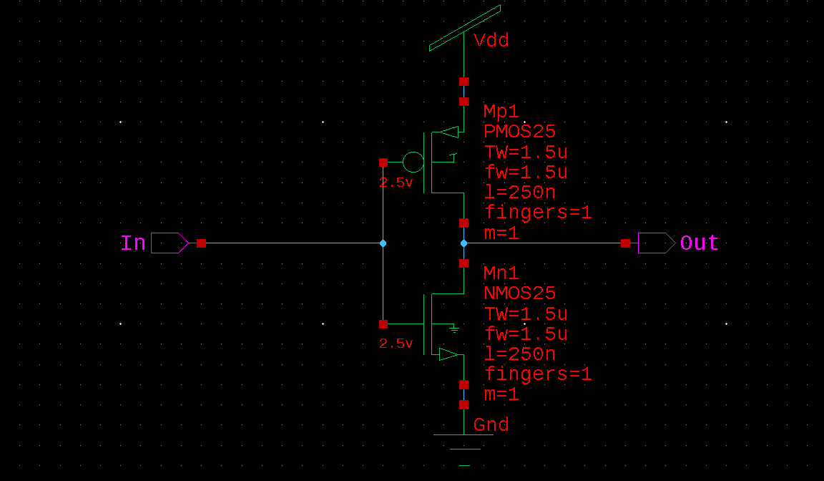

I did not add the voltage sources vbit or vdc here because they would interfere with LVS and PEX. I add them in when I need to simulate the circuit to observe the waveforms for correctness.

Cell Layout in L-Edit
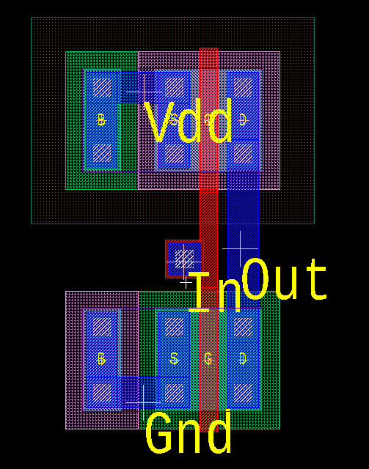

A simple inverter layout that was published straight from S-Edit. The I/O ports were placed using Box Ports.

Check for design rule violations

DRC Summary
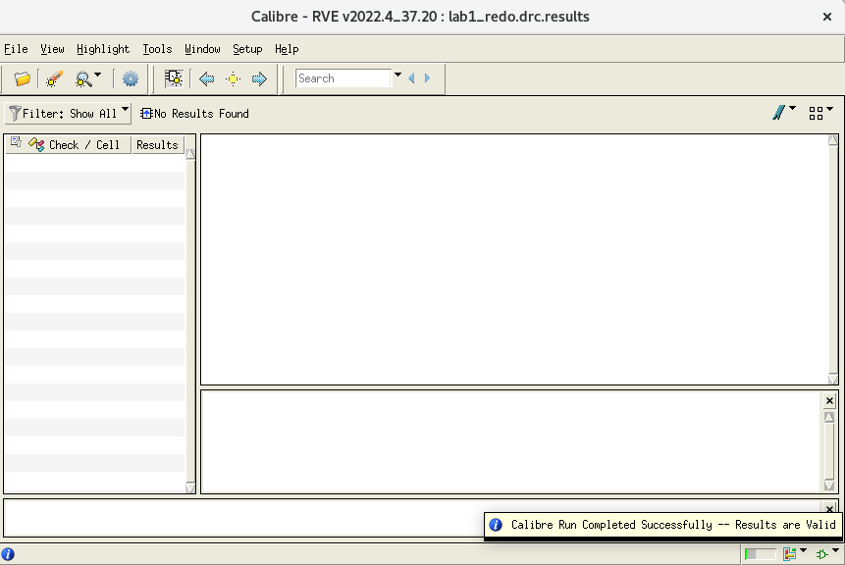
After running DRC, the following popup windows are shown:

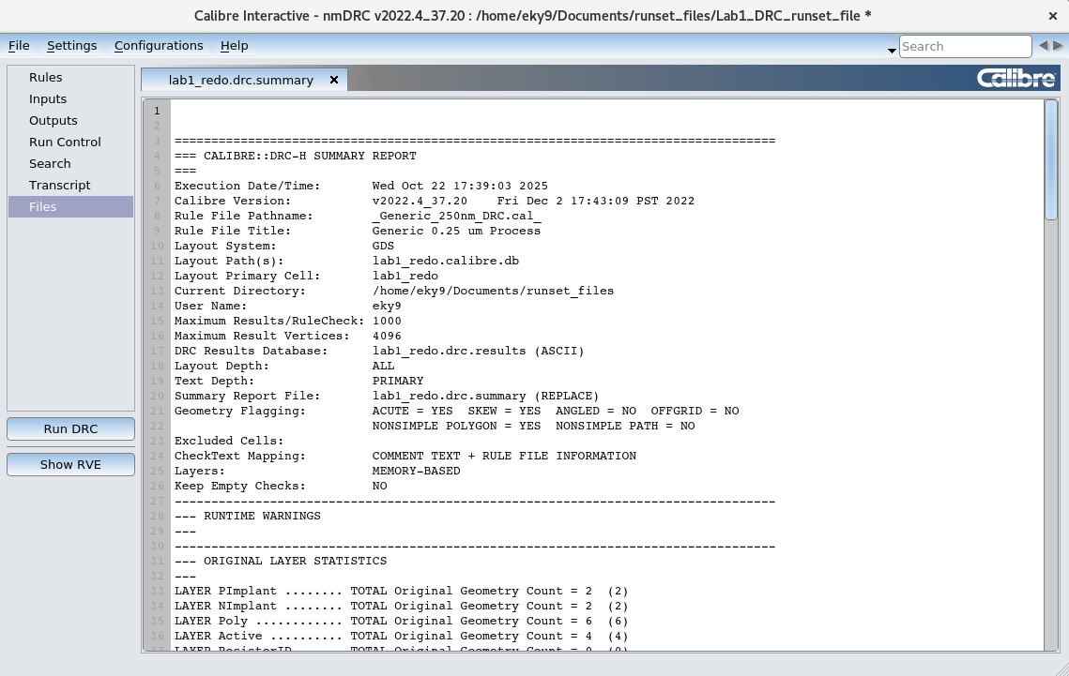

I have copied and pasted the full DRC summary below:

==================================================================================
=== CALIBRE::DRC-H SUMMARY REPORT
===
Execution Date/Time: Wed Oct 22 10:34:55 2025
Calibre Version: v2022.4_37.20 Fri Dec 2 17:43:09 PST 2022
Rule File Pathname: _Generic_250nm_DRC.cal_
Rule File Title: Generic 0.25 um Process
Layout System: GDS
Layout Path(s): lab1_redo.calibre.db
Layout Primary Cell: lab1_redo
Current Directory: /home/eky9/Documents/runset_files
User Name: eky9
Maximum Results/RuleCheck: 1000
Maximum Result Vertices: 4096
DRC Results Database: lab1_redo.drc.results (ASCII)
Layout Depth: ALL
Text Depth: PRIMARY
Summary Report File: lab1_redo.drc.summary (REPLACE)
Geometry Flagging: ACUTE = YES SKEW = YES ANGLED = NO OFFGRID = NO
NONSIMPLE POLYGON = YES NONSIMPLE PATH = NO
Excluded Cells:
CheckText Mapping: COMMENT TEXT + RULE FILE INFORMATION
Layers: MEMORY-BASED
Keep Empty Checks: NO
----------------------------------------------------------------------------------
--- RUNTIME WARNINGS
---
----------------------------------------------------------------------------------
--- ORIGINAL LAYER STATISTICS
---
LAYER PImplant ........ TOTAL Original Geometry Count = 2 (2)
LAYER NImplant ........ TOTAL Original Geometry Count = 2 (2)
LAYER Poly ............ TOTAL Original Geometry Count = 6 (6)
LAYER Active .......... TOTAL Original Geometry Count = 4 (4)
LAYER ResistorID ...... TOTAL Original Geometry Count = 0 (0)
LAYER DeepNWell ....... TOTAL Original Geometry Count = 0 (0)
LAYER Contact ......... TOTAL Original Geometry Count = 13 (13)
LAYER ThickActive ..... TOTAL Original Geometry Count = 0 (0)
LAYER TCP ............. TOTAL Original Geometry Count = 0 (0)
LAYER Via3 ............ TOTAL Original Geometry Count = 0 (0)
LAYER SilicideBlock ... TOTAL Original Geometry Count = 0 (0)
LAYER Passivation ..... TOTAL Original Geometry Count = 0 (0)
LAYER Metal4 .......... TOTAL Original Geometry Count = 0 (0)
LAYER Metal1 .......... TOTAL Original Geometry Count = 16 (16)
LAYER NWell ........... TOTAL Original Geometry Count = 1 (1)
LAYER Metal2 .......... TOTAL Original Geometry Count = 0 (0)
LAYER Metal3 .......... TOTAL Original Geometry Count = 0 (0)
LAYER PWell ........... TOTAL Original Geometry Count = 0 (0)
LAYER Via1 ............ TOTAL Original Geometry Count = 0 (0)
LAYER Via2 ............ TOTAL Original Geometry Count = 0 (0)
----------------------------------------------------------------------------------
--- RULECHECK RESULTS STATISTICS
---
RULECHECK NW.SD ......... TOTAL Result Count = 0 (0)
RULECHECK NW.FS ......... TOTAL Result Count = 0 (0)
RULECHECK NW.W .......... TOTAL Result Count = 0 (0)
RULECHECK NW.S .......... TOTAL Result Count = 0 (0)
RULECHECK DNW.W ......... TOTAL Result Count = 0 (0)
RULECHECK DNW.S ......... TOTAL Result Count = 0 (0)
RULECHECK DNW.SNW ....... TOTAL Result Count = 0 (0)
RULECHECK NW.ODNW ....... TOTAL Result Count = 0 (0)
RULECHECK NW.XDNW ....... TOTAL Result Count = 0 (0)
RULECHECK PW.W .......... TOTAL Result Count = 0 (0)
RULECHECK PW.S .......... TOTAL Result Count = 0 (0)
RULECHECK NIm.S ......... TOTAL Result Count = 0 (0)
RULECHECK PIm.S ......... TOTAL Result Count = 0 (0)
RULECHECK NIm.W ......... TOTAL Result Count = 0 (0)
RULECHECK PIm.W ......... TOTAL Result Count = 0 (0)
RULECHECK Im.NP ......... TOTAL Result Count = 0 (0)
RULECHECK Im.XAc ........ TOTAL Result Count = 0 (0)
RULECHECK Ac.W .......... TOTAL Result Count = 0 (0)
RULECHECK Ac.S .......... TOTAL Result Count = 0 (0)
RULECHECK Ac.SPW ........ TOTAL Result Count = 0 (0)
RULECHECK Ac.SNW ........ TOTAL Result Count = 0 (0)
RULECHECK Ac.SCW ........ TOTAL Result Count = 0 (0)
RULECHECK Ac.SSCW ....... TOTAL Result Count = 0 (0)
RULECHECK Ac.AcIm ....... TOTAL Result Count = 0 (0)
RULECHECK ThAc.O ........ TOTAL Result Count = 0 (0)
RULECHECK Ac.XP ......... TOTAL Result Count = 0 (0)
RULECHECK Ac.XSb ........ TOTAL Result Count = 0 (0)
RULECHECK ThAc.W ........ TOTAL Result Count = 0 (0)
RULECHECK ThAc.S ........ TOTAL Result Count = 0 (0)
RULECHECK ThAc.SAc ...... TOTAL Result Count = 0 (0)
RULECHECK Po.W .......... TOTAL Result Count = 0 (0)
RULECHECK Po.WHV ........ TOTAL Result Count = 0 (0)
RULECHECK Po.S .......... TOTAL Result Count = 0 (0)
RULECHECK Po.SPAc ....... TOTAL Result Count = 0 (0)
RULECHECK Po.XAc ........ TOTAL Result Count = 0 (0)
RULECHECK Po.SAc ........ TOTAL Result Count = 0 (0)
RULECHECK Po.XSb ........ TOTAL Result Count = 0 (0)
RULECHECK Co.W .......... TOTAL Result Count = 0 (0)
RULECHECK Co.S .......... TOTAL Result Count = 0 (0)
RULECHECK Co.SG ......... TOTAL Result Count = 0 (0)
RULECHECK Co.EPo ........ TOTAL Result Count = 0 (0)
RULECHECK Co.EAc ........ TOTAL Result Count = 0 (0)
RULECHECK Co.EIm ........ TOTAL Result Count = 0 (0)
RULECHECK Co.AcGt ....... TOTAL Result Count = 0 (0)
RULECHECK M1.W .......... TOTAL Result Count = 0 (0)
RULECHECK M1.S .......... TOTAL Result Count = 0 (0)
RULECHECK M1.SW ......... TOTAL Result Count = 0 (0)
RULECHECK M1.SL ......... TOTAL Result Count = 0 (0)
RULECHECK M1.V1 ......... TOTAL Result Count = 0 (0)
RULECHECK V1.W .......... TOTAL Result Count = 0 (0)
RULECHECK V1.S .......... TOTAL Result Count = 0 (0)
RULECHECK M2.W .......... TOTAL Result Count = 0 (0)
RULECHECK M2.S .......... TOTAL Result Count = 0 (0)
RULECHECK M2.SW ......... TOTAL Result Count = 0 (0)
RULECHECK M2.SL ......... TOTAL Result Count = 0 (0)
RULECHECK M2.V1 ......... TOTAL Result Count = 0 (0)
RULECHECK M2.V2 ......... TOTAL Result Count = 0 (0)
RULECHECK V2.W .......... TOTAL Result Count = 0 (0)
RULECHECK V2.S .......... TOTAL Result Count = 0 (0)
RULECHECK M3.W .......... TOTAL Result Count = 0 (0)
RULECHECK M3.S .......... TOTAL Result Count = 0 (0)
RULECHECK M3.SW ......... TOTAL Result Count = 0 (0)
RULECHECK M3.SL ......... TOTAL Result Count = 0 (0)
RULECHECK M3.V2 ......... TOTAL Result Count = 0 (0)
RULECHECK M3.V3 ......... TOTAL Result Count = 0 (0)
RULECHECK V3.W .......... TOTAL Result Count = 0 (0)
RULECHECK V3.S .......... TOTAL Result Count = 0 (0)
RULECHECK M4.W .......... TOTAL Result Count = 0 (0)
RULECHECK M4.S .......... TOTAL Result Count = 0 (0)
RULECHECK M4.SW ......... TOTAL Result Count = 0 (0)
RULECHECK M4.SL ......... TOTAL Result Count = 0 (0)
RULECHECK M4.V3 ......... TOTAL Result Count = 0 (0)
RULECHECK M4.EP ......... TOTAL Result Count = 0 (0)
RULECHECK Pad.SM4 ....... TOTAL Result Count = 0 (0)
RULECHECK Pad.SM3 ....... TOTAL Result Count = 0 (0)
RULECHECK Pad.SM2 ....... TOTAL Result Count = 0 (0)
RULECHECK Pad.SM1 ....... TOTAL Result Count = 0 (0)
RULECHECK Pad.SPo ....... TOTAL Result Count = 0 (0)
RULECHECK Pad.SAc ....... TOTAL Result Count = 0 (0)
RULECHECK Sb.W .......... TOTAL Result Count = 0 (0)
RULECHECK Sb.S .......... TOTAL Result Count = 0 (0)
RULECHECK Sb.SCo ........ TOTAL Result Count = 0 (0)
RULECHECK Sb.SAc ........ TOTAL Result Count = 0 (0)
RULECHECK Sb.SPo ........ TOTAL Result Count = 0 (0)
RULECHECK Sb.WPo ........ TOTAL Result Count = 0 (0)
RULECHECK Sb.SRes ....... TOTAL Result Count = 0 (0)
RULECHECK Sb.EPo ........ TOTAL Result Count = 0 (0)
RULECHECK Sb.EAc ........ TOTAL Result Count = 0 (0)
RULECHECK Sb.SGate ...... TOTAL Result Count = 0 (0)
RULECHECK Pass.W ........ TOTAL Result Count = 0 (0)
RULECHECK M1Gt.A ........ TOTAL Result Count = 0 (0)
RULECHECK PoM1Gt.A ...... TOTAL Result Count = 0 (0)
RULECHECK PoM1Gt.AMPo ... TOTAL Result Count = 0 (0)
RULECHECK PoM1Gt.AMM1 ... TOTAL Result Count = 0 (0)
RULECHECK PoM1Gt.AM ..... TOTAL Result Count = 0 (0)
RULECHECK PoM1Gt.ANd1 ... TOTAL Result Count = 0 (0)
RULECHECK PoM1Gt.ANd2 ... TOTAL Result Count = 0 (0)
----------------------------------------------------------------------------------
--- RULECHECK RESULTS STATISTICS (BY CELL)
---
----------------------------------------------------------------------------------
--- SUMMARY
---
TOTAL CPU Time: 0
TOTAL REAL Time: 0
TOTAL Original Layer Geometries: 44 (44)
TOTAL DRC RuleChecks Executed: 97
TOTAL DRC Results Generated: 0 (0)

LVS Report
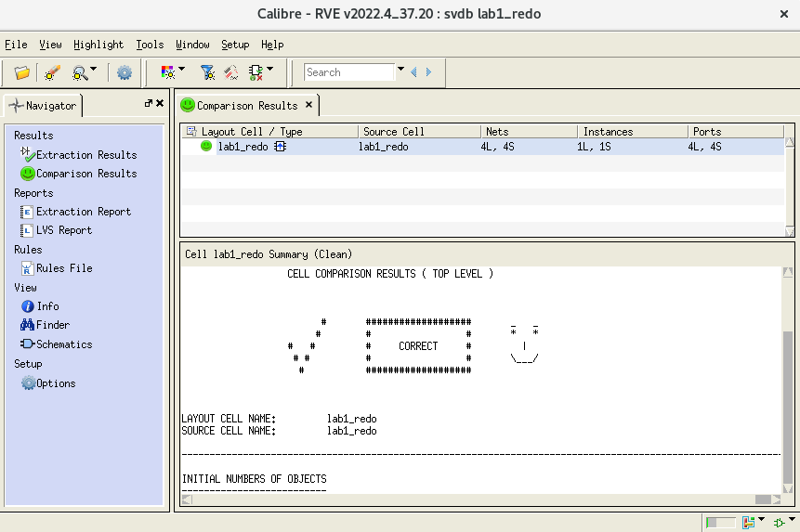
After running LVS, the following popup windows are shown:

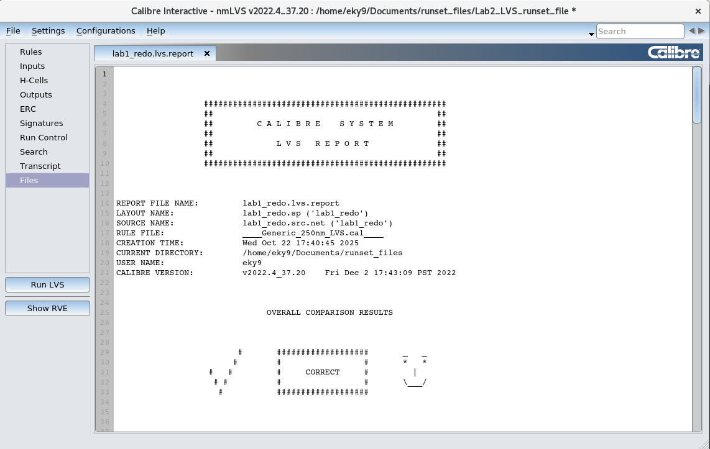

I have copied and pasted the full LVS Report below:

##################################################
## ##
## C A L I B R E S Y S T E M ##
## ##
## L V S R E P O R T ##
## ##
##################################################

REPORT FILE NAME: lab1_redo.lvs.report
LAYOUT NAME: svdb/lab1_redo.sp ('lab1_redo')
SOURCE NAME: lab1_redo.src.net ('lab1_redo')
RULE FILE: ____Generic_250nm_xRC.cal____
CREATION TIME: Wed Oct 22 17:42:19 2025
CURRENT DIRECTORY: /home/eky9/Documents/runset_files
USER NAME: eky9
CALIBRE VERSION: v2022.4_37.20 Fri Dec 2 17:43:09 PST 2022

OVERALL COMPARISON RESULTS

# ################### _ _
# # # * *
# # # CORRECT # |
# # # # \___/
# ###################

**************************************************************************************************************
CELL SUMMARY
**************************************************************************************************************

Result Layout Source
----------- ----------- --------------
CORRECT lab1_redo lab1_redo

**************************************************************************************************************
LVS PARAMETERS
**************************************************************************************************************

o LVS Setup:

// LVS COMPONENT TYPE PROPERTY
// LVS COMPONENT SUBTYPE PROPERTY
// LVS PIN NAME PROPERTY
// LVS POWER NAME
// LVS GROUND NAME
LVS CELL SUPPLY NO
LVS RECOGNIZE GATES ALL
// LVS HCELL REPORT
LVS IGNORE PORTS NO
LVS CHECK PORT NAMES NO
LVS IGNORE TRIVIAL NAMED PORTS NO
LVS BUILTIN DEVICE PIN SWAP YES
LVS ALL CAPACITOR PINS SWAPPABLE NO
LVS DISCARD PINS BY DEVICE NO
LVS SOFT SUBSTRATE PINS NO
LVS INJECT LOGIC NO
LVS EXPAND UNBALANCED CELLS YES
LVS FLATTEN INSIDE CELL NO
LVS EXPAND SEED PROMOTIONS NO
LVS PRESERVE PARAMETERIZED CELLS NO
LVS GLOBALS ARE PORTS YES
LVS RELAX INITIAL CPOINTS NONE
LVS REVERSE WL NO
// LVS NETLIST FILTER DEVICES NO
// LVS PRESERVE BOX PORTS NO
LVS SPICE PREFER PINS NO
LVS SPICE SLASH IS SPACE YES
LVS SPICE ALLOW FLOATING PINS YES
// LVS SPICE ALLOW INLINE PARAMETERS
LVS SPICE ALLOW UNQUOTED STRINGS NO
LVS SPICE CONDITIONAL LDD NO
LVS SPICE CULL PRIMITIVE SUBCIRCUITS NO
// LVS SPICE EXCLUDE CELL SOURCE
// LVS SPICE EXCLUDE CELL LAYOUT
LVS SPICE IMPLIED MOS AREA NO
// LVS SPICE MULTIPLIER NAME
LVS SPICE OVERRIDE GLOBALS NO
LVS SPICE REDEFINE PARAM NO
LVS SPICE REPLICATE DEVICES NO
LVS SPICE SCALE X PARAMETERS NO
LVS SPICE STRICT WL NO
// LVS SPICE OPTION
LVS STRICT SUBTYPES NO
LVS EXACT SUBTYPES NO
LAYOUT CASE YES
SOURCE CASE YES
LVS COMPARE CASE NO
LVS COMPARE CASE STRICT NO
LVS DOWNCASE DEVICE NO
LVS REPORT MAXIMUM 50
LVS PROPERTY RESOLUTION MAXIMUM 32
// LVS SIGNATURE MAXIMUM
// LVS FILTER UNUSED OPTION
// LVS REPORT OPTION
LVS REPORT UNITS YES
LVS SWAPPABLE HCELL PINS GENERAL
// LVS NON USER NAME PORT
// LVS NON USER NAME NET
// LVS NON USER NAME INSTANCE
// LVS IGNORE DEVICE PIN
// LVS PREFER NETS FILTER SOURCE
// LVS PREFER NETS FILTER LAYOUT
LVS PREFER PORT NETS NO
LVS EXPAND ON ERROR NO
LVS EXPAND AMBIGUOUSLY HIGH SHORTED HCELLS NO

// Reduction

LVS REDUCE SERIES MOS NO
LVS REDUCE PARALLEL MOS YES
LVS REDUCE SEMI SERIES MOS NO
LVS REDUCE SPLIT GATES YES
LVS REDUCE PARALLEL BIPOLAR YES
LVS REDUCE SERIES CAPACITORS YES
LVS REDUCE PARALLEL CAPACITORS YES
LVS REDUCE SERIES RESISTORS YES
LVS REDUCE PARALLEL RESISTORS YES
LVS REDUCE PARALLEL DIODES YES
LVS REDUCTION PRIORITY PARALLEL

LVS SHORT EQUIVALENT NODES NO

// Trace Property

TRACE PROPERTY mn l l 0
TRACE PROPERTY mn w w 0
TRACE PROPERTY mp l l 0
TRACE PROPERTY mp w w 0
TRACE PROPERTY m l l 0
TRACE PROPERTY m w w 0
TRACE PROPERTY c l l 0.5
TRACE PROPERTY c w w 0.5
TRACE PROPERTY c c c 0.5
TRACE PROPERTY r l l 0.5
TRACE PROPERTY r w w 0.5
TRACE PROPERTY r r r 0.5

CELL COMPARISON RESULTS ( TOP LEVEL )

# ################### _ _
# # # * *
# # # CORRECT # |
# # # # \___/
# ###################

LAYOUT CELL NAME: lab1_redo
SOURCE CELL NAME: lab1_redo

--------------------------------------------------------------------------------------------------------------

NUMBERS OF OBJECTS
------------------

Layout Source Component Type
------ ------ --------------
Ports: 4 4

Nets: 4 4

Instances: 1 1 MN (4 pins)
1 1 MP (4 pins)
------ ------
Total Inst: 2 2

**************************************************************************************************************
INFORMATION AND WARNINGS
**************************************************************************************************************

Matched Matched Unmatched Unmatched Component
Layout Source Layout Source Type
------- ------- --------- --------- ---------
Ports: 4 4 0 0

Nets: 4 4 0 0

Instances: 1 1 0 0 MN(NMOS25)
1 1 0 0 MP(PMOS25)
------- ------- --------- ---------
Total Inst: 2 2 0 0

o Initial Correspondence Points:

Ports: Vdd Gnd Out In

**************************************************************************************************************
SUMMARY
**************************************************************************************************************

Total CPU Time: 0 sec
Total Elapsed Time: 0 sec

PEX Report
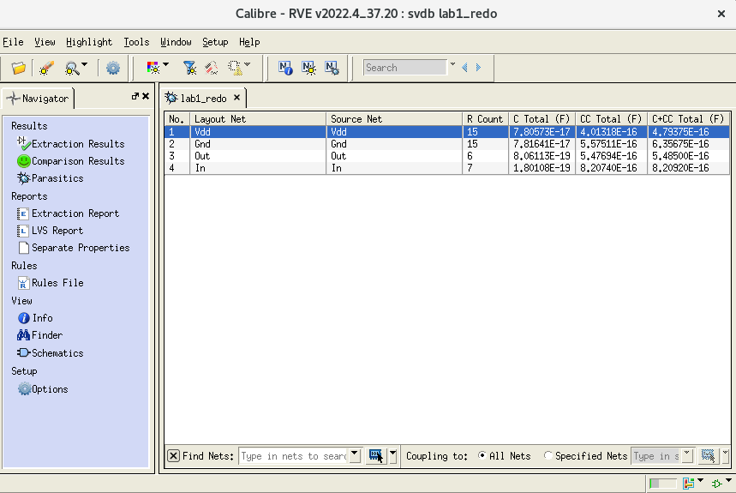
After running PEX, the following popup windows are shown:

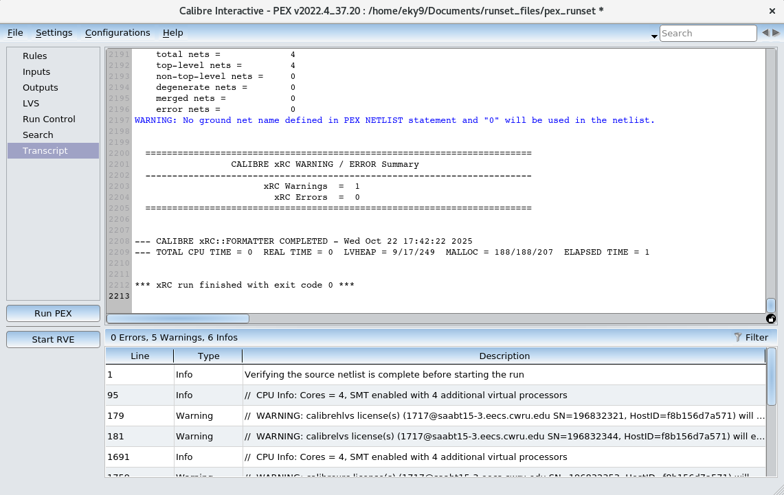

Instead of copy and pasting the PEX report, I have copied and pasted the .pxi and .pex.netlist files below:

.PXI file
* File: lab1_redo.pex.netlist.lab1_redo.pxi
* Created: Wed Oct 22 17:42:22 2025
*
x_PM_lab1_redo_Vdd N_Vdd_MMp1_b N_Vdd_MMp1_s Vdd N_Vdd_c_1_p N_Vdd_c_2_p
+ PM_lab1_redo_Vdd
x_PM_lab1_redo_Gnd N_Gnd_MMn1_b N_Gnd_MMn1_s Gnd N_Gnd_c_13_n N_Gnd_c_18_p
+ N_Gnd_c_14_n PM_lab1_redo_Gnd
x_PM_lab1_redo_Out N_Out_MMn1_d N_Out_c_32_n N_Out_MMp1_d N_Out_c_28_n Out
+ N_Out_c_29_n PM_lab1_redo_Out
x_PM_lab1_redo_In N_In_MMn1_g N_In_MMp1_g N_In_c_43_n In PM_lab1_redo_In
cc_1 N_Vdd_c_1_p N_Gnd_c_13_n 0.00521787f
cc_2 N_Vdd_c_2_p N_Gnd_c_14_n 0.00196786f
cc_3 N_Vdd_MMp1_b N_Out_c_28_n 0.00201822f
cc_4 N_Vdd_MMp1_b N_Out_c_29_n 0.112665f
cc_5 N_Vdd_MMp1_s N_Out_c_29_n 2.43033e-19
cc_6 N_Vdd_c_2_p N_Out_c_29_n 0.0367286f
cc_7 N_Vdd_MMp1_b N_In_MMp1_g 0.184358f
cc_8 N_Vdd_MMp1_s N_In_MMp1_g 0.00804171f
cc_9 N_Vdd_c_2_p N_In_MMp1_g 0.036422f
cc_10 N_Vdd_MMp1_s N_In_c_43_n 0.00647975f
cc_11 N_Vdd_c_2_p N_In_c_43_n 0.00192861f
cc_12 N_Vdd_c_2_p In 0.00524696f
cc_13 N_Gnd_MMn1_b N_Out_c_32_n 0.00201822f
cc_14 N_Gnd_MMn1_b N_Out_c_29_n 0.145061f
cc_15 N_Gnd_MMn1_s N_Out_c_29_n 2.43033e-19
cc_16 N_Gnd_c_18_p N_Out_c_29_n 0.0367286f
cc_17 N_Gnd_MMn1_b N_In_MMn1_g 0.159054f
cc_18 N_Gnd_MMn1_s N_In_MMn1_g 0.00804171f
cc_19 N_Gnd_c_18_p N_In_MMn1_g 0.036422f
cc_20 N_Gnd_MMn1_b N_In_MMp1_g 0.019039f
cc_21 N_Gnd_MMn1_b N_In_c_43_n 0.0916886f
cc_22 N_Gnd_MMn1_s N_In_c_43_n 0.0137125f
cc_23 N_Gnd_c_14_n N_In_c_43_n 0.00279098f
cc_24 N_Gnd_MMn1_b In 0.0247527f
cc_25 N_Gnd_c_14_n In 0.0107728f
cc_26 N_Out_c_32_n N_In_MMn1_g 0.0175592f
cc_27 N_Out_c_29_n N_In_MMn1_g 0.159948f
cc_28 N_Out_c_28_n N_In_MMp1_g 0.0175592f
cc_29 N_Out_c_29_n In 0.0169224f

.PEX.NETLIST FILE
* File: lab1_redo.pex.netlist
* Created: Wed Oct 22 17:42:22 2025
* Program "Calibre xRC"
* Version "v2022.4_37.20"
*
.include "lab1_redo.pex.netlist.pex"
.subckt lab1_redo In Out Gnd Vdd
*
* In In
* Out Out
* Gnd Gnd
* Vdd Vdd
XMMn1 N_Out_MMn1_d N_In_MMn1_g N_Gnd_MMn1_s N_Gnd_MMn1_b NMOS25 L=2.5e-07
+ W=1.5e-06 AD=9.75e-13 AS=9.75e-13 PD=4.3e-06 PS=4.3e-06
XMMp1 N_Out_MMp1_d N_In_MMp1_g N_Vdd_MMp1_s N_Vdd_MMp1_b PMOS25 L=2.5e-07
+ W=1.5e-06 AD=9.75e-13 AS=9.75e-13 PD=4.3e-06 PS=4.3e-06
*
.include "lab1_redo.pex.netlist.lab1_redo.pxi"
*
.ends
*
*

Simulation of the waveforms for correctness
For the following simulations, I will show the waveforms in pairs. The first waveform will be the original, unaltered waveform, while the second waveform will take into account the parasitic capacitance data that was obtained through PEX.

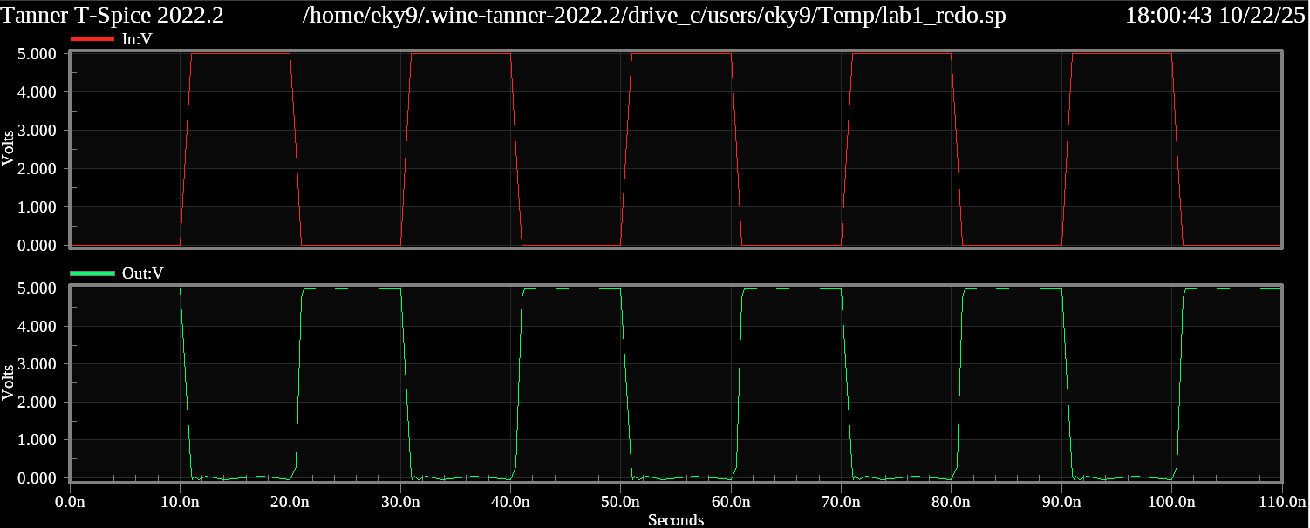
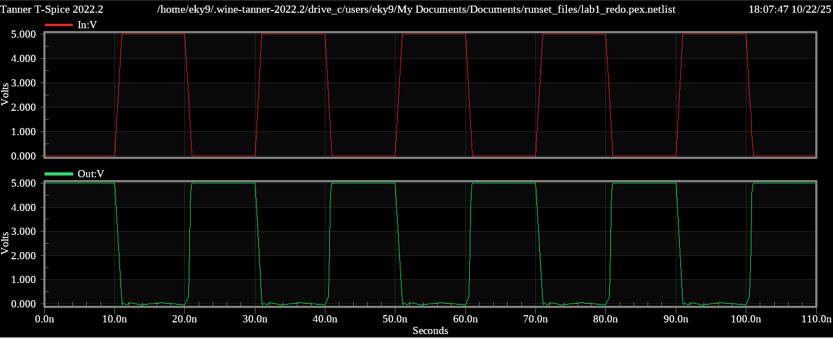

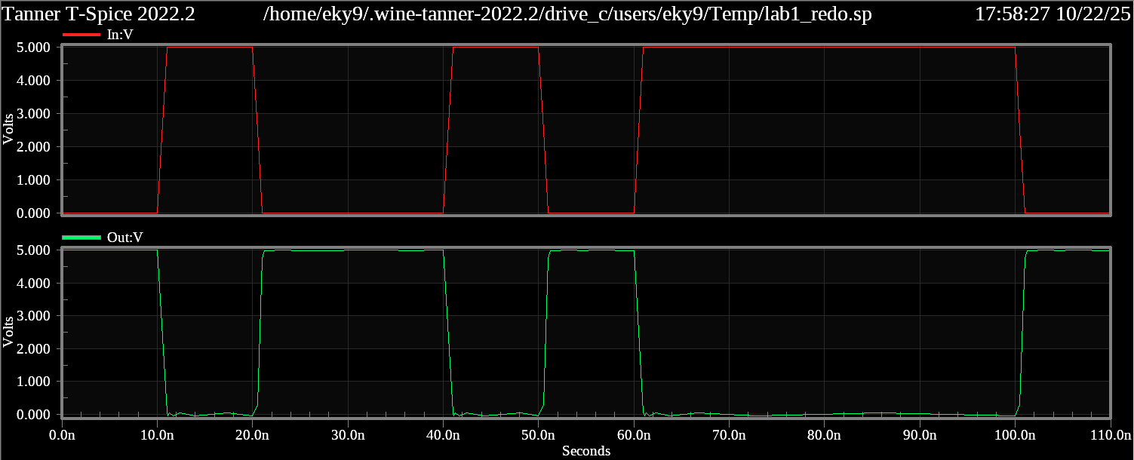
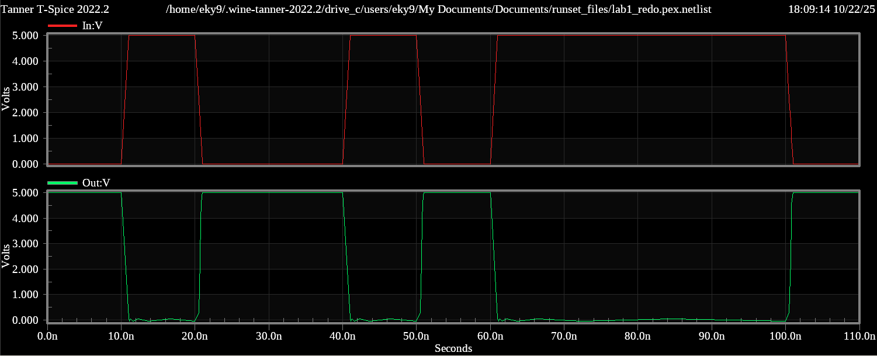

First of all, the waveforms show correctness of the circuit since the output waveform is always the opposite of the input waveform. This is what we expect to see since we designed an inverter in S-Edit and L-Edit. Second, we can see from these pairs of waveforms that parasitic capacitance seemingly does not affect the output of the waveform. This is not true, as all inverters are affected by parasitic capacitance, but in this case, as shown from the PEX popup windows, the effect of the capacitance is so small that it simply seems like there is no change in output.

Another thing to note, none of the nodes in this inverter exhibit degradation in voltage levels. This is because NMOS passes strong zeros and PMOS passes strong ones, and if you look at the inverter, that is all they will ever pass to the output.

Updated .pex.netlist for parasitic capacitance simulation
* File: lab1_redo.pex.netlist
* Created: Wed Oct 22 17:42:22 2025
* Program "Calibre xRC"
* Version "v2022.4_37.20"
*
.include "lab1_redo.pex.netlist.pex"
.INCLUDE "/home/eky9/TannerEDA/tspice.inc"
.LIB "/home/eky9/TannerEDA/TannerTools_v2022.2/Process/Generic_250nm/Models/spice/generic_250nm.lib" TT
.subckt lab1_redo In Out Gnd Vdd
*
* In In
* Out Out
* Gnd Gnd
* Vdd Vdd
XMMn1 N_Out_MMn1_d N_In_MMn1_g N_Gnd_MMn1_s N_Gnd_MMn1_b NMOS25 L=2.5e-07
+ W=1.5e-06 AD=9.75e-13 AS=9.75e-13 PD=4.3e-06 PS=4.3e-06
XMMp1 N_Out_MMp1_d N_In_MMp1_g N_Vdd_MMp1_s N_Vdd_MMp1_b PMOS25 L=2.5e-07
+ W=1.5e-06 AD=9.75e-13 AS=9.75e-13 PD=4.3e-06 PS=4.3e-06
*
.include "lab1_redo.pex.netlist.lab1_redo.pxi"
*
.ends
xDUT In Out Gnd Vdd lab1_redo
VV1 Vdd Gnd DC 5 $ $x=6600 $y=4200 $w=400 $h=600
VV2 In Gnd BIT({0100101111} ) $ $x=3500 $y=4100 $w=400 $h=600
.PLOT V(In) $ $x=2850 $y=4550 $w=1500 $h=300 $r=180
.PLOT V(Out) $ $x=5550 $y=5150 $w=300 $h=1500 $r=270
.TRAN 10n 110n
*
*.

Lab 1 Redo SPICE Netlist
* SPICE export by: S-Edit 2022.2.2
* Export time: Wed Oct 22 09:56:24 2025
* Design path: /home/eky9/ECSE485/Labs/lib.defs
* Library: Labs
* Cell: lab1_redo_sym
* Testbench: Spice
* View: schematic1
* Export as: top-level cell
* Export mode: hierarchical
* Exclude empty: yes
* Exclude .model: no
* Exclude .hdl: no
* Exclude .end: no
* Expand paths: yes
* Wrap lines: no
* Exclude simulator commands: no
* Exclude global pins: no
* Exclude instance locations: no
* Control property name(s): SPICE

********* Simulation Settings - General Section *********
*************** Subcircuits ***************
.subckt lab1_redo In Out Gnd Vdd
* Library name: Labs
* Cell name: lab1_redo
* View name: schematic
* PORT=Out TYPE=Out
* PORT=Gnd TYPE=Other
* PORT=Vdd TYPE=Other
* PORT=In TYPE=In

XMn1 Out In Gnd Gnd NMOS25 w=1.5u l=250n m=1 ad=975f pd=4.3u as=975f ps=4.3u nrd=433.33333m nrs=433.33333m mult=1 delvto=0 mulu0=1 $ $x=4500 $y=4000 $w=400 $h=600
XMp1 Out In Vdd Vdd PMOS25 w=1.5u l=250n m=1 ad=975f pd=4.3u as=975f ps=4.3u nrd=433.33333m nrs=433.33333m mult=1 delvto=0 mulu0=1 $ $x=4500 $y=4800 $w=400 $h=600
.ends

***** Top Level *****
Xlab1_redo_1 In Out Gnd Vdd lab1_redo $ $x=5000 $y=3900 $w=1800 $h=1400

********* Simulation Settings - Analysis Section *********

********* Simulation Settings - Additional SPICE Commands *********

.end

